**International Islamic University Chittagong**

Department of Computer Science and Engineering



***Property Trading System***

A Modern Real Estate Property Management

***Submitted to:***

*Md. Shahriar Younus Ashik*

*Adj. Faculty*

*Department of Computer Science and Engineering*

*International Islamic University, Chittagong*

***Submitted by:***

1. *Ameer Hamzah Daiyan (C231185)*
2. *Mohammed Junaid Mahmud (C231189)*

***1. Background of The Subject***

Real estate property management has witnessed significant advancements in recent times, backed by compelling statistics. According to a survey conducted by the National Association of Realtors (NAR), 82% of property managers now use property management software to streamline operations and improve efficiency. Online listing platforms have also gained prominence, with 94% of tenants and owners searching for properties online, as reported by the Pew Research Center. Additionally, the adoption of smart home technology has risen by 33% in the past three years, enhancing the tenant experience and increasing energy efficiency, according to a study by Statista. These statistics highlight the tangible impact of technology and innovation on the real estate property management industry.

***2. Problem Statement***

In the perspective of our subject, there will be two types of customers who will use us as a media for helping to find out great deals for them.

Types of Customers:

* Owners
* Tenants

We have made a system which has two separate sections according to the types of customers. In the system, firstly, owners will can add the details of their properties as much as they want and they will be assured if their properties will be perfectly saved or not. On the other hand, in the system, tenants will see the details of properties so that they will can choose as they will want to pay for the rent. People of both side will can easily use this system for their own facilities and save their valuable times.

***3. Objectives***

* To let a owner add his/her properties through the system.
* To let a tenant see the viewed properties through the system.
* To smoothen the trading system for both the owners and tenants.

***4. Features***

* **Property Addition:**

Allow users to add new properties to the management system, including property details such as address, number of bedrooms, price.

* **Property Listing:**

Display a list of all properties in the system, showing relevant information for each property.

* **Property Update:**

Enable users to update property details such as address, price, or number of bedrooms.

* **Property Deletion:**

Provide the ability to delete properties from the system.

***5. Modules***

* **Add Property:**

The user will be prompted to enter the property address, number of bedrooms, and price.

* **View Properties:**

The property details such as ID, address, number of bedrooms, and price will be displayed to the user which will be saved.

* **Update Property:**

The user will be prompted to enter the ID of the property they want to update. Then the module will search for the property based on the entered ID. If the property will be found, the user will be prompted to enter the updated address, number of bedrooms, and price. The details will be updated in the program. If the property will not be found, a message will be displayed accordingly.

* **Delete Property:**

The user will be prompted to enter the ID of the property they want to delete. Then the module will search for the property based on the entered ID. If the property will be found, the property will be removed. If the property will not be found, a message will be displayed accordingly.

* **Save Properties:**

The property details such as ID, address, number of bedrooms, and price will be saved in a file. If the file will fail to open, an error message will be displayed. Then the module will write the details of the properties. A success message will be displayed upon successful saving of the properties.

* **Exit program:**

When will be called, it will display a message indicating the program is exiting.

***6. Data Flow Diagram:***

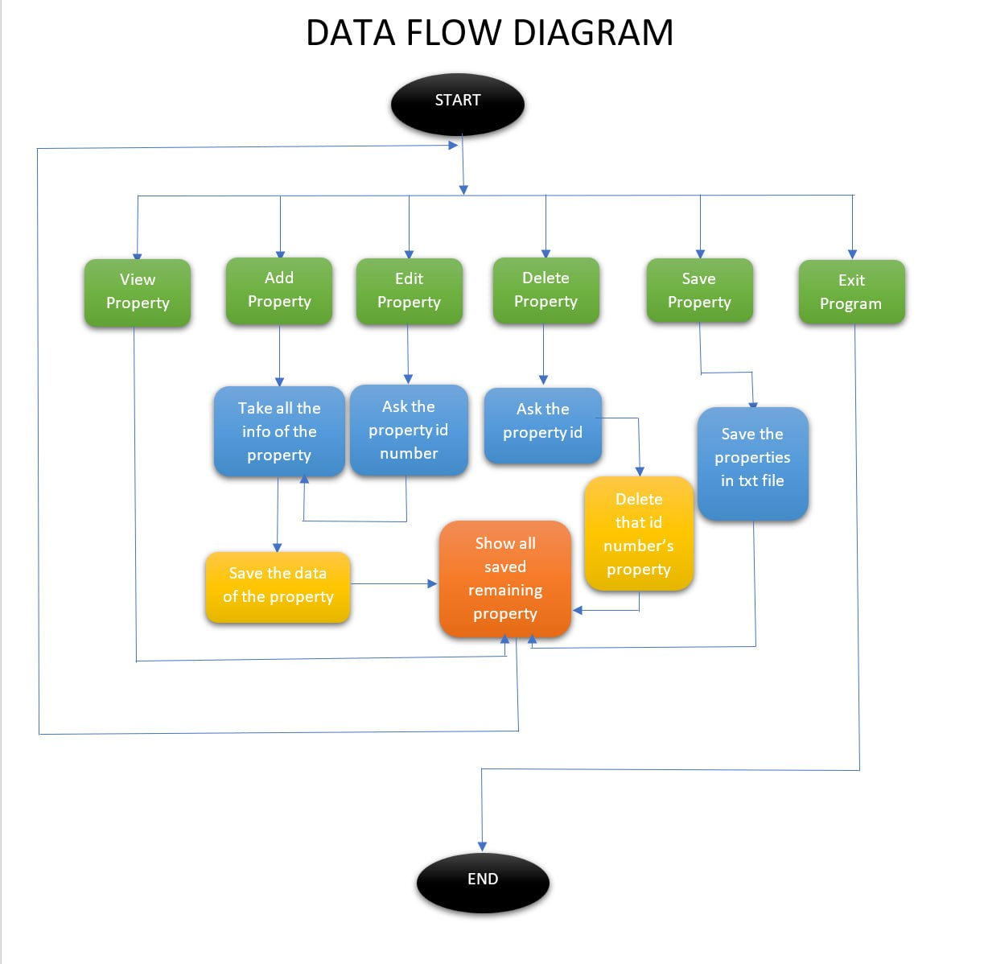

***7. System Requirements***

1. **Software Requirements**

* **OS:** Microsoft Windows based any compatible OS e.g. Windows 10
* **IDE:** Code::Blocks, VS Code
* **Browser:** Google Chrome, Brave
* **Conversational AI:** ChatGPT

1. **Hardware Requirements**

* Processor: Intel Core i3 or equivalent
* RAM: 4 GB
* Storage: 10 GB

***8. Expected Outcome:***

Multiple positive benefits are expected – not only helping the customers but also impacting in improving the network, economy and saving times. Because as far as we know, TIME IS MONEY.